**BCS2303 WEB SCRYPTING MINI PROJECT**

TAXI BOOKING ONLINE SYSTEM

LECTURER: DR. ERIC LIEW SIAU CHUI

|  |  |  |
| --- | --- | --- |
| NO | NAME | ID |
| 1 | NURFARIZAN BINTI ZAILANI | CD14044 |
| 2 | MUFHIRAH BINTI MOHD SALLEH | CD14013 |
| 3 | NABILAH BINTI RUZA | CB15013 |

CONTENT

1. OBJECTIVE -------------------------------------------------------3
2. SCHEDULE ------------------------------------------------------3
3. DESCRIPTION ------------------------------------------------------5
4. EXPECTED BENEFIT ------------------------------------------------------5
5. FLOWCHART ------------------------------------------------------5
6. WEBPAGE ------------------------------------------------------6
7. SOLUTION ------------------------------------------------------13
8. REFERENCE ----------------------------------------------------------------13

OBJECTIVE

* To facilitate the user in using the website.
* To record the user’s data
* To avoid user spending more than the amount they are supposed to
* To make change from manual record to system record

SCHEDULE

DATE: 29 OCTOBER 2016

TIME: (9:00AM-12:00PM)

PLACE: CAFETERIA KK3

|  |
| --- |
| NURFARIZAN BINTI ZAILANI |
| NABILAH BINTI RUZA |

DATE: 5 NOVEMBER 2016

TIME: (9:00AM-12:00PM)

PLACE: CAFETERIA KK3

|  |
| --- |
| NURFARIZAN BINTI ZAILANI |
| NABILAH BINTI RUZA |

DATE: 7 NOVEMBER 2016

TIME: (10:00AM-12:00PM)

PLACE: FSK21

|  |
| --- |
| NURFARIZAN BINTI ZAILANI |
| NABILAH BINTI RUZA |

DATE: 12 NOVEMBER 2016

TIME: (9:00AM-12:00PM)

PLACE: CAFETERIA KK3

|  |
| --- |
| NURFARIZAN BINTI ZAILANI |
| NABILAH BINTI RUZA |

DATE: 14 NOVEMBER 2016

TIME: (10:00AM-12:00PM)

PLACE: FSK21

|  |
| --- |
| NURFARIZAN BINTI ZAILANI |
| NABILAH BINTI RUZA |

DATE: 23 NOVEMBER 2016

TIME: (10:00AM-12:00PM)

PLACE: ZDK-07

|  |
| --- |
| NURFARIZAN BINTI ZAILANI |
| NABILAH BINTI RUZA |

DATE: 5 DECEMBER 2016

TIME: (10:00AM-12:00PM)

PLACE: FSK21

|  |
| --- |
| NURFARIZAN BINTI ZAILANI |
| NABILAH BINTI RUZA |

DESCRIPTION

This website will enable the user to search for their desired journey with the simplest and easiest way. The website has a few functions which is login, register, booking, feedback and report. Each function will have a huge impact for the system.

EXPECTED BENEFIT

* Customer can estimate their budget from the shown price
* Ease the customer’s need to go from a place to place
* Ease the taxi driver to estimate their passenger and type of car that they need to drive for the day

FLOWCHART

N

Y

FULL_NAME, DOB, H/P,EMAIL ,PASSWORD, CONFIRM_PASSWORD

PRINT

BOOKING:

NAME,EMAIL,DEPARTURE,ARRIVAL,DATE,TIME,PAYMENT,BANK TYPE,BANK ACCOUNT,PAYMENT(RM)

EMAIL NAME,

PASSWORD

MEMBER?

WEBPAGE DESIGN

1. HOME

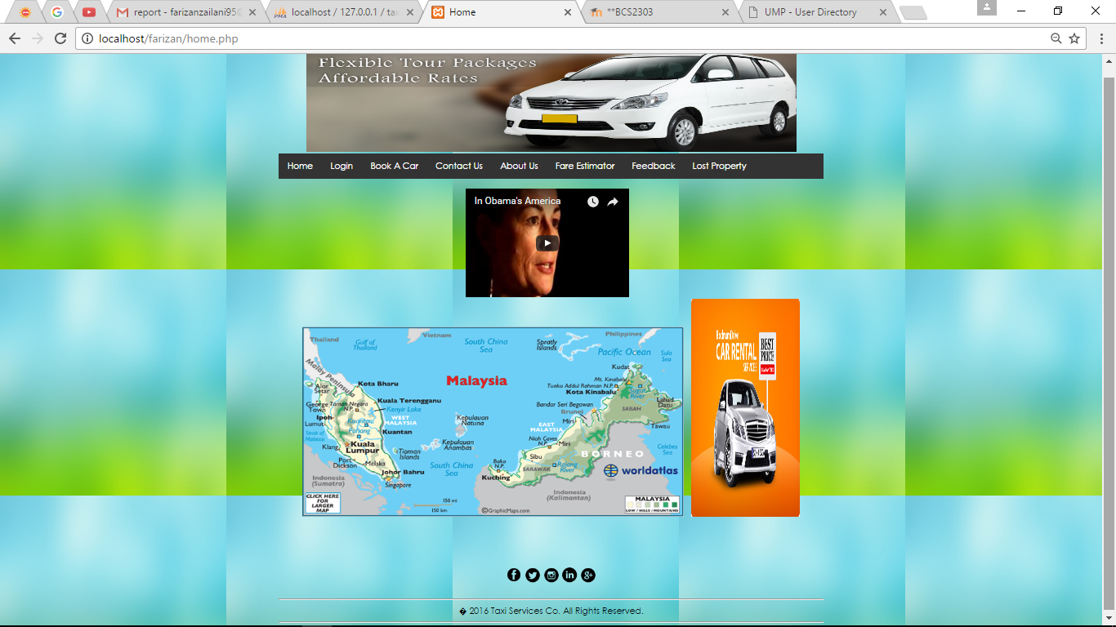

1. LOGIN

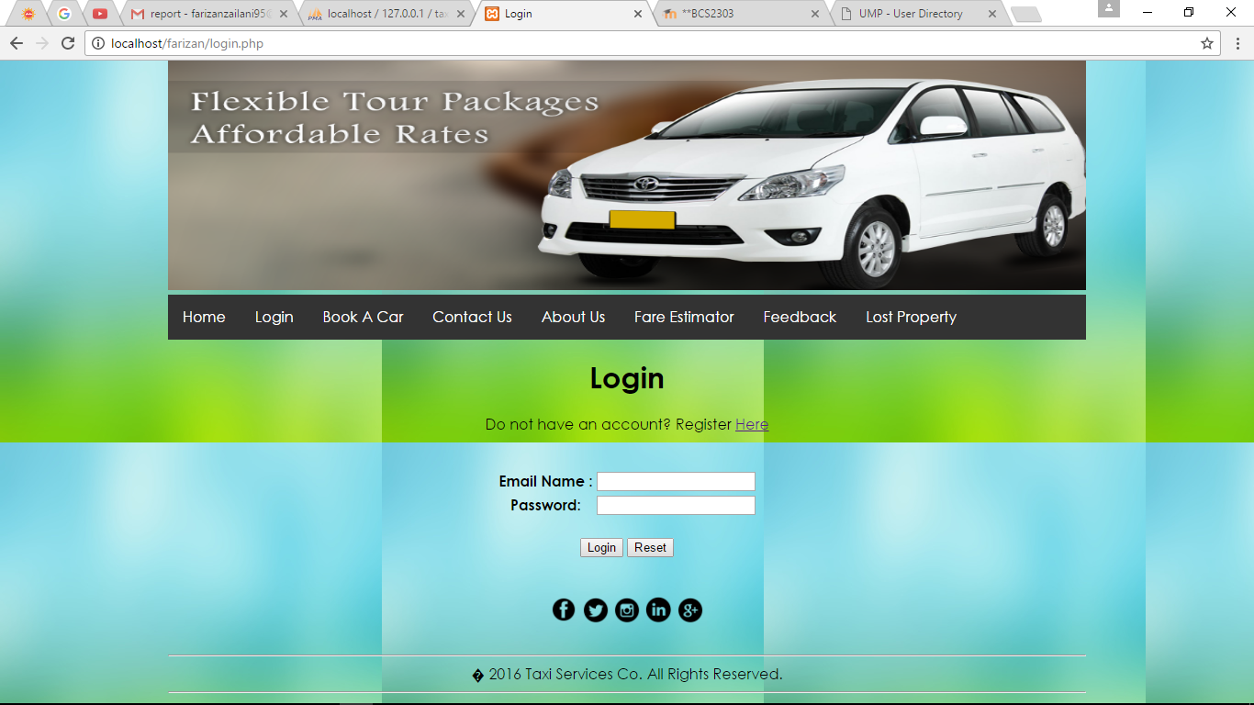

1. BOOKING

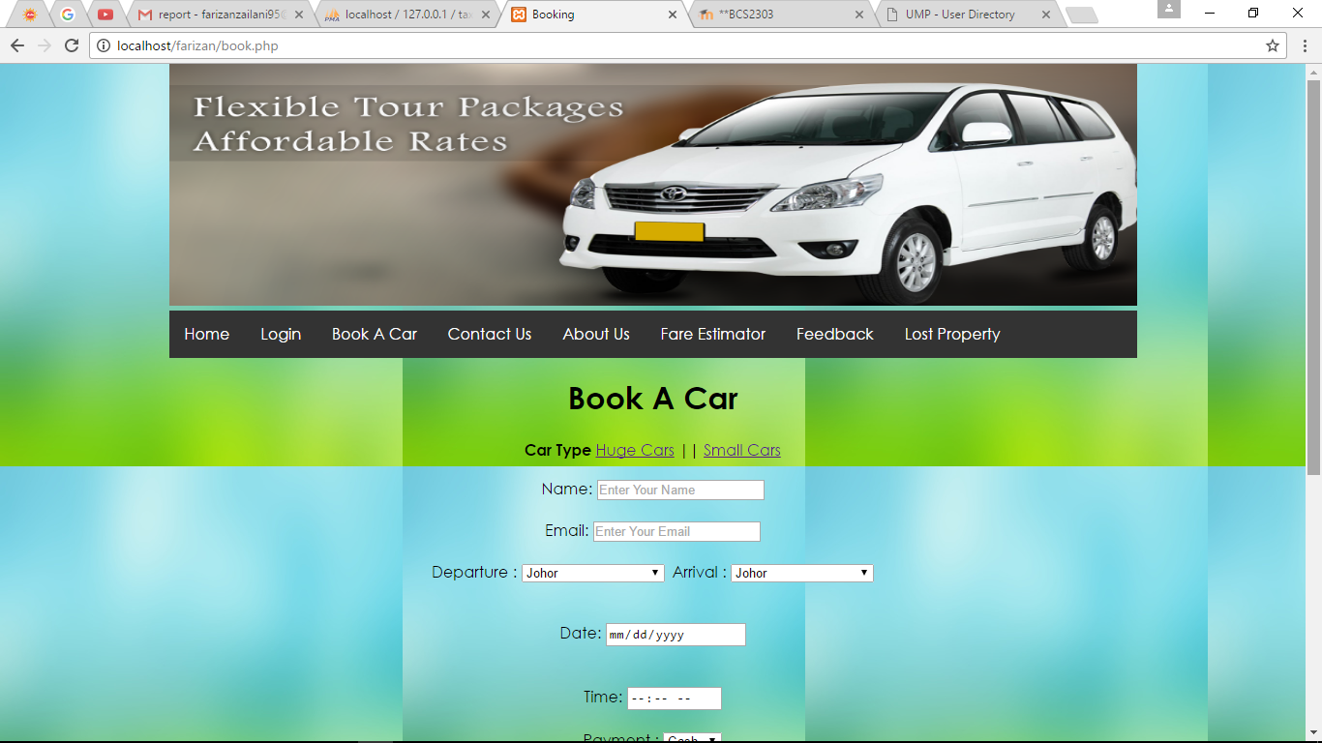

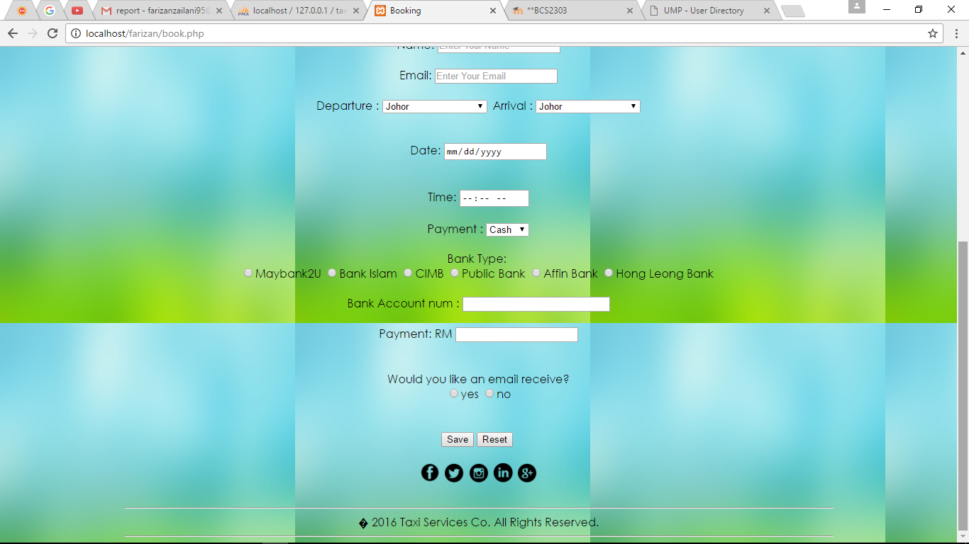

1. CONTACT US

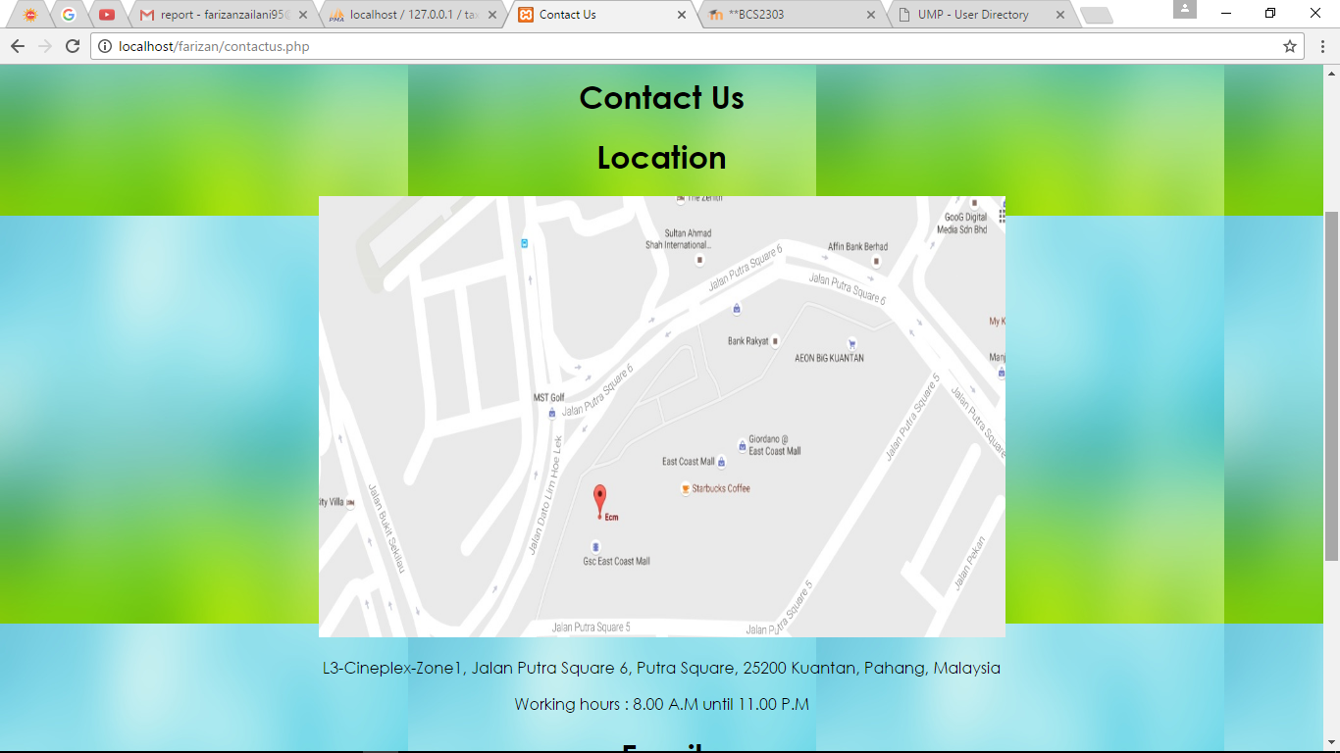

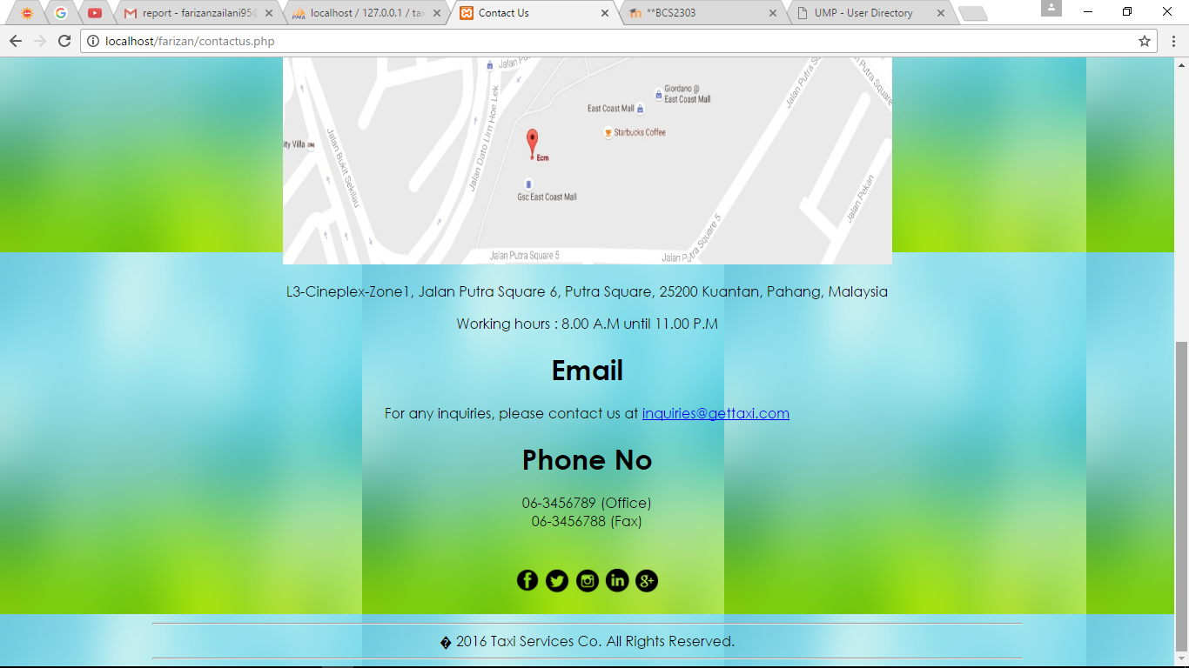

1. ABOUT US

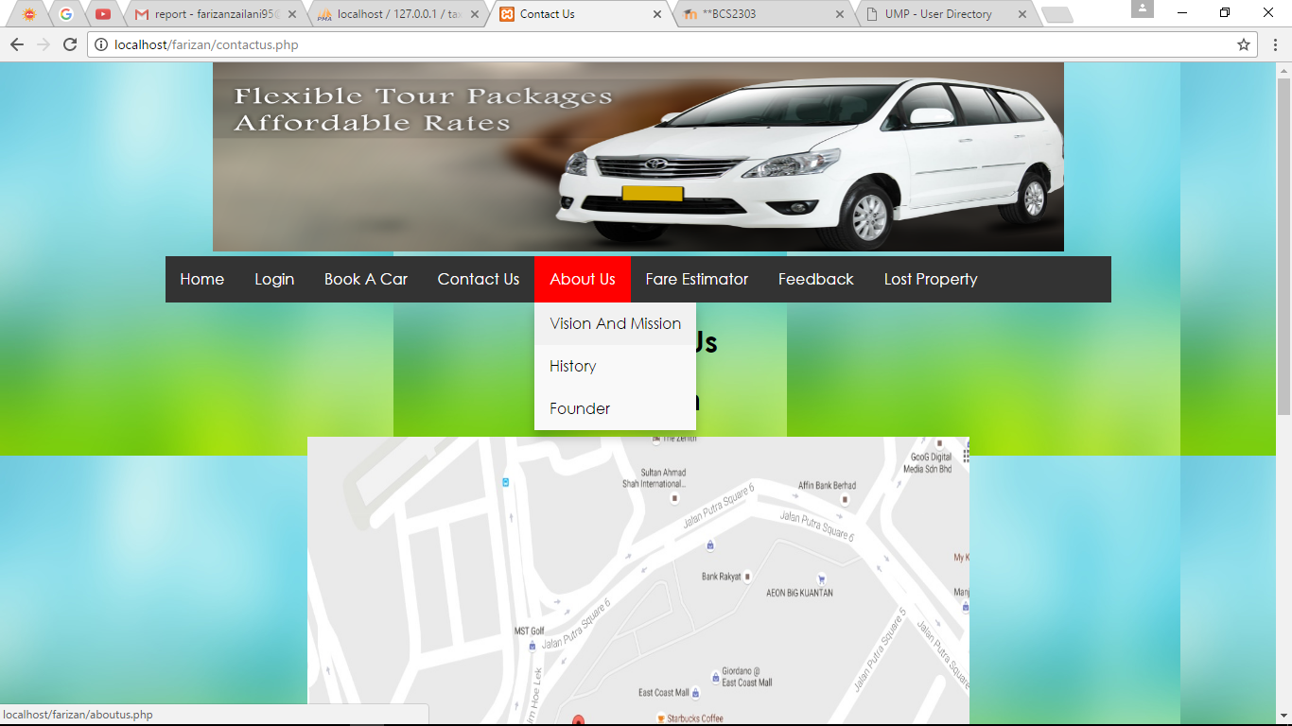

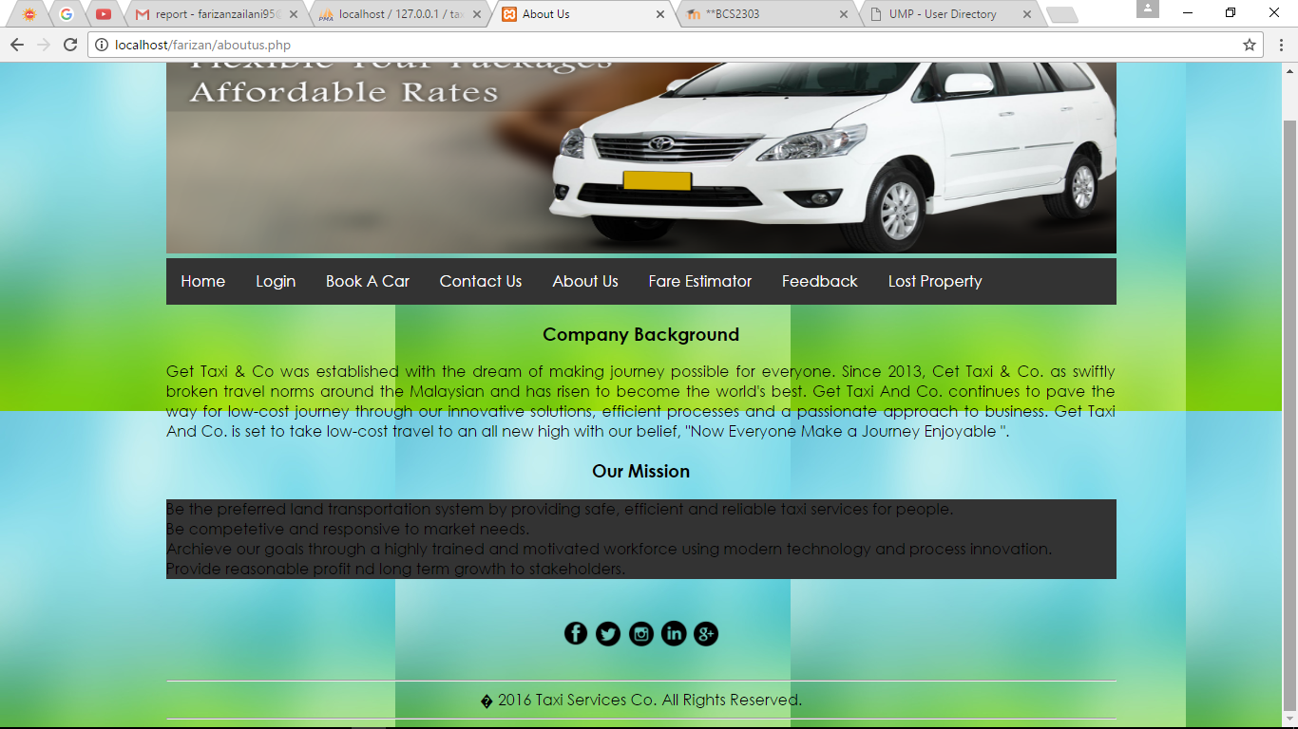

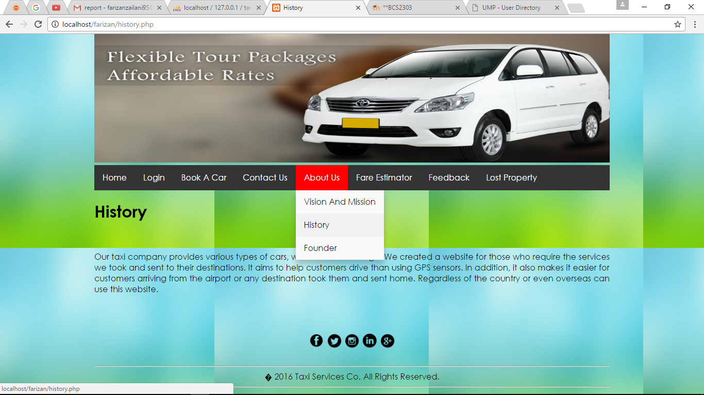

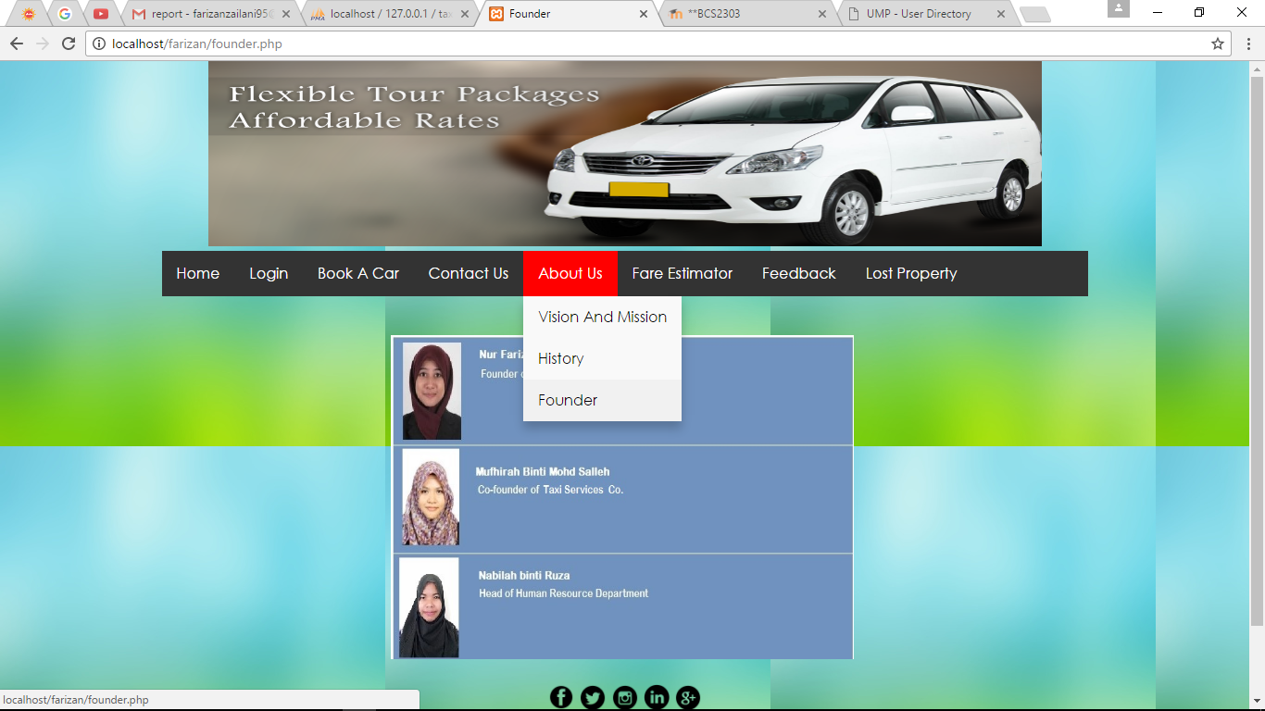

1. FARE ESTIMATOR

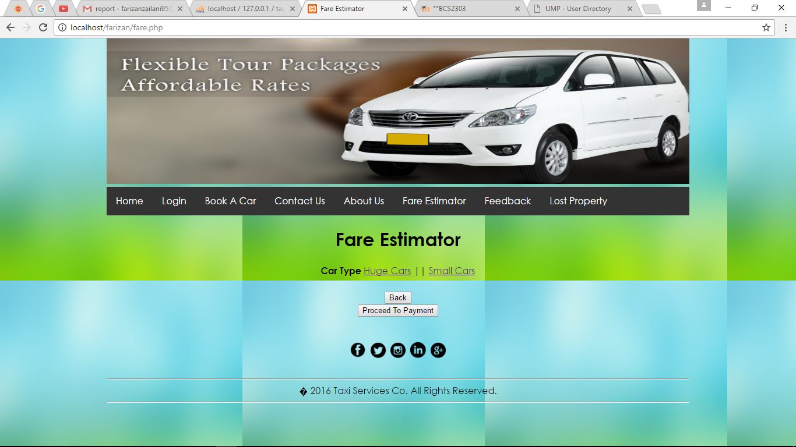

1. FEEDBACK

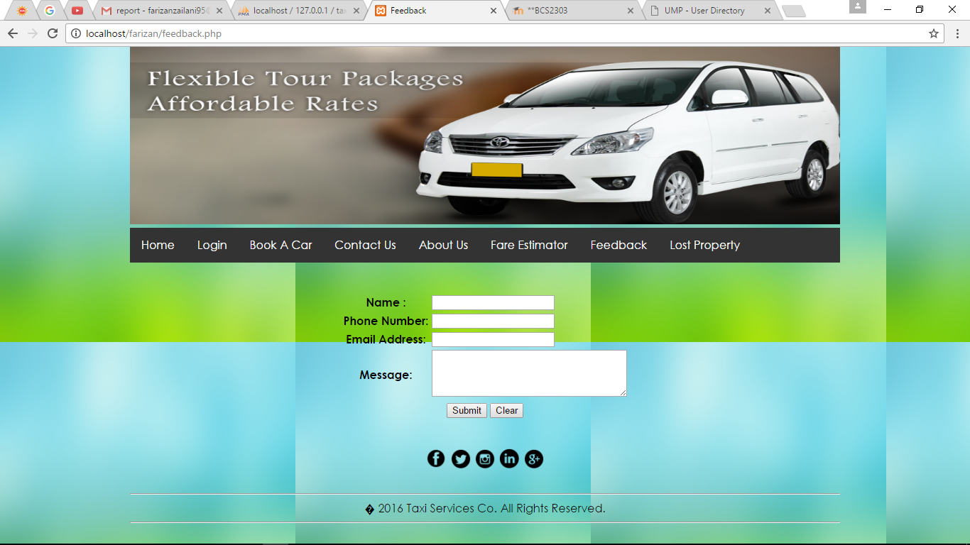

1. LOST PROPERTY

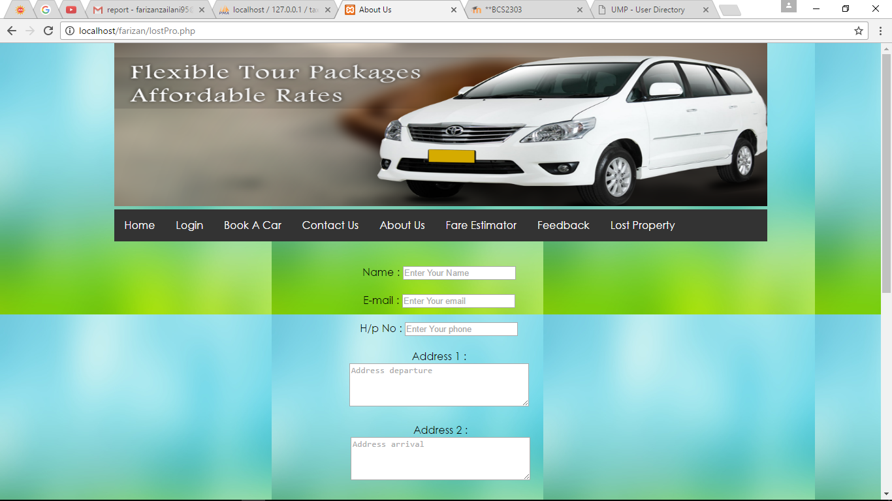

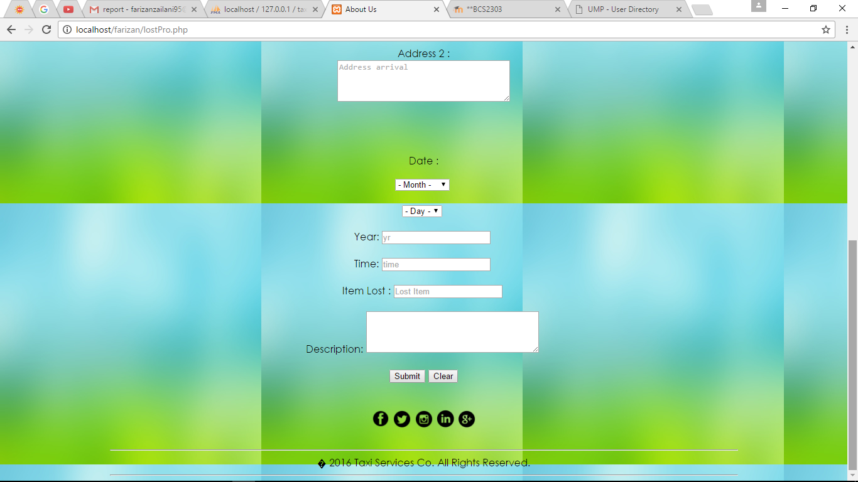

SOLUTION

By using our website, the user can easily find the right taxi for them that are trustworthy and easy to use.

REFERENCE

<https://www.airasiago.com.my/>

<http://www.w3schools.com/tags/tag_button.asp>

<http://www.w3schools.com/howto/howto_js_dropdown.asp>

<http://inspirationalpixels.com/tutorials/creating-a-dropdown-menu-with-html-css>

<http://www.homeandlearn.co.uk/WD/wds5pA.html>

<http://html-color-codes.info/>

<https://www.youtube.com/watch?v=e8TP2FERKls>

<https://www.youtube.com/watch?v=J2-neLr7MXM>

<https://www.youtube.com/watch?v=ueWpNe0PG34>